**Cinderella Man**

**Viewing Guide**

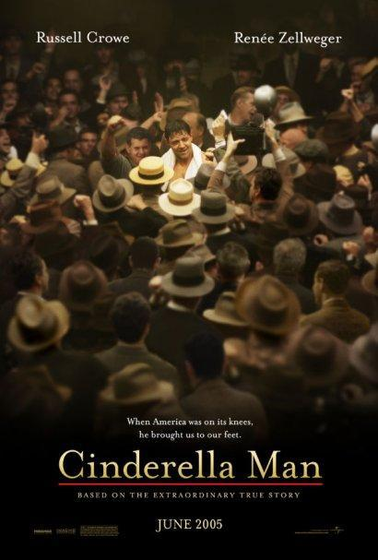

DIRECTIONS:

1. Read the discussion questions before viewing.
2. Based on your knowledge of the Great Depression and on what is depicted in the film, answer the discussion questions after viewing the movie.
3. **Submit answers to discussion questions. Must be typed!**

**Cinderella Man Discussion Questions**



1. How do the visual texture of the film and the music combine to portray the hopelessness and despair of the Great Depression? How do the visual and audio aspects of the film create meaning?

The visual texture of this film displays hopelessness through the use of dark lighting in the bad times, for instance when the power goes out, or in the ring when he’s losing Jimmy is darker than his opponent. Also on the cover of the film, which represents Jimmy winning he is light, to represent his prosperity, whereas everyone else is dark to represent the bad times of the rest of the world , and everyone coming towards Jimmy represents them being enlightened to hope by him.

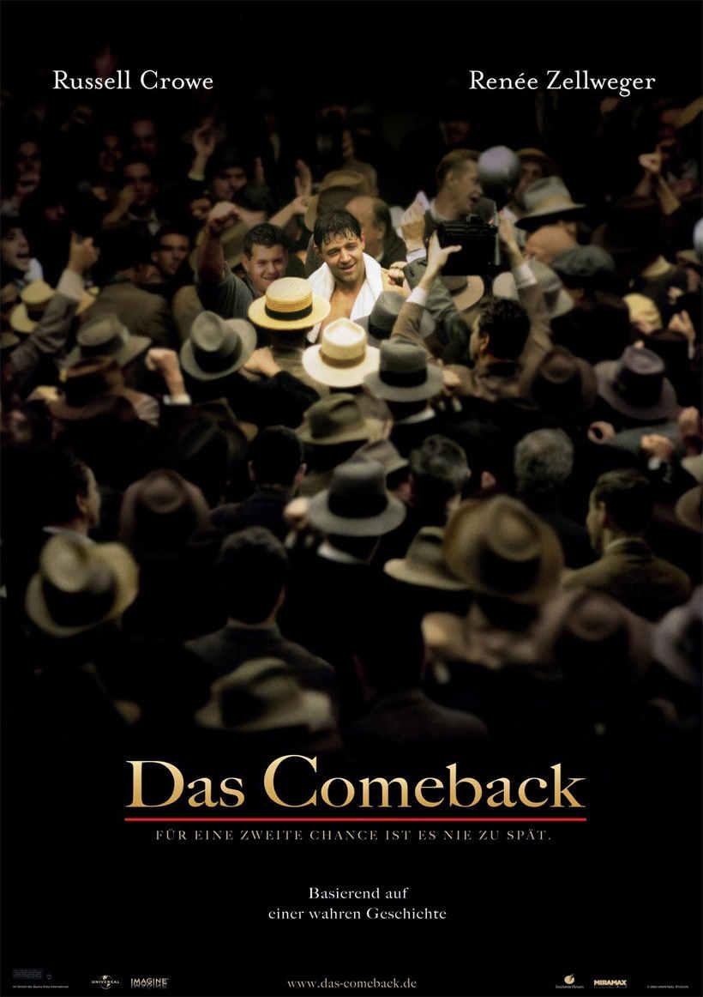

The visual and audio aspects of the film that create meaning are firstly in the fight the punches. How they are seen through jimmy’s view point, the blurred vision, the slowing of time, it creates a sense of empathy from the viewer for Jimmy. It is also present in the hoovervilles. The whole hoover-ville is dark and dismal characterizing hopelessness.

1. “Character is what you do when no one is looking.”
   1. How does Jimmy’s character shape his destiny?

Jimmy’s character is one of hard work and perseverance, and is shaped by the hardships he has had to endure. As he is forced to watch his family suffer, his work ethic grows until it is so strong he is able to compete with the best boxer in the world.

* 1. What did you think about the scene in which Jimmy has to take his son to return the salami he has stolen? What did the scene tell us about Jimmy’s character and his relationship with his son/children? What were Jimmy and Mae’s beliefs about their family, their children?

That despite all the hardships they had been through character, and ethics always prevail. This also portrays that no matter what they go threw, they will always have their humanity.

1. Taking the role of a man with a family living during the Depression, explain how it feels to be out of work. Why does Jimmy give back the money he “borrowed” from the government?

Being out of work is extremely difficult because, as a man, I claim the sole responsibility of making enough money so my family can eat, and that they have a comfortable place to live. Therefore any lack of those needs being met is a personal failure on my part. He gave the borrowed money back to the government because he was ashamed to have borrowed it in the first place.

1. This movie was based on a true story. Explain why Jim Braddock became such a hero to the people living out the Great Depression day by day. Even if this was a purely fictional tale, explain why Braddock’s story in the boxing ring is the perfect parallel as an allegory.

He is proof that with hope and ambition one can come back from anything

1. What did the film mean to you? Describe how the film made you feel. Did you like the film? Why or why not?

This film demonstrated the perseverance of the human spirit.